

**UNIVERSITY OF PETROLEUM AND ENERGY STUDIES**

**School of Computer** **Science**

**2020-21**

**GRAPHICS AND ANIMATION TOOLS LAB**

**Faculty: Dr. DURGANSH SHARMA**

**Assistant Professor**

**Department of Cybernetics.**

**School of Computer Science, UPES**

**Submitted By:**

**Name- Vaibhav Kansal**

**Roll no-R100217086**

**Batch-B3**

**Semester- 7**

**Course-B.tech. CSE-OSOS**

**Sap Id- 500061579**

**Experiment 10**

Steps to create Building

1. Open Blender workspace erase the current shape and Click on the add option and add a 3D square.

2. Then we will make a few changes in the shape like length and expansiveness.

3. After creation changes in the shape we will choose the upper essence of the 3D square and afterward expel it. Like this, we will expand the length of our structure.

4. After this add edge circles to make windows of the structure.

5. Now add new material on the windows and set harshness to 0 and transmission to1.

6. Now go to the concealing part and add different properties like commotion surface, knock, and so forth to give reasonable consequences for windows.

7. Extrude the lower piece of the structure outwards to make the state of the door 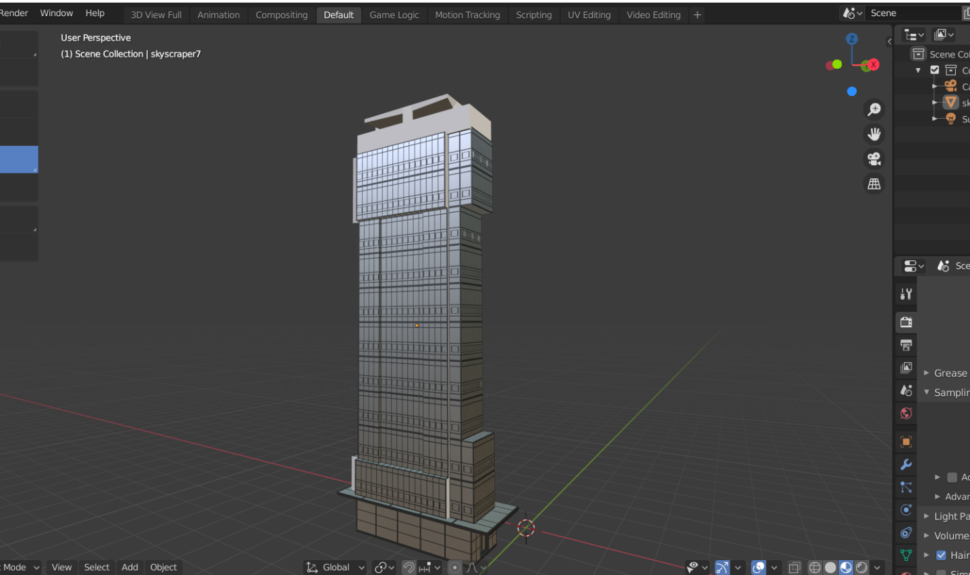accordingly.